Namespaces in Python

Virtually everything that a Python program uses or acts on is an object. Even a short program will create many different objects. In a more complex program, they’ll probably number in the thousands. Python has to keep track of all these objects and their names, and it does so with namespaces.
A namespace is a collection of currently defined symbolic names along with information about the object that each name references. You can think of a namespace as a dictionary in which the keys are the object names and the values are the objects themselves. Each key-value pair maps a name to its corresponding object.

In a Python program, there are four types of namespaces:
- Built-In
- Global
- Enclosing
- Local
These have different lifetimes. As Python executes a program, it creates namespaces as necessary and deletes them when they’re no longer needed. Typically, many namespaces will exist at any given time.

The Built-In Namespace
The built-in namespace contains the names of all of Python’s built-in objects. These are available at all times when Python is running. You can list the objects in the built-in namespace with the following command:
dir(__builtins__)

The Python interpreter creates the built-in namespace when it starts up. This namespace remains in existence until the interpreter terminates.

The Global Namespace
The global namespace contains any names defined at the level of the main program. Python creates the global namespace when the main program body starts, and it remains in existence until the interpreter terminates.
Strictly speaking, this may not be the only global namespace that exists. The interpreter also creates a global namespace for any module that your program loads with the import statement.

The globals() function
The built-in function globals() returns a reference to the current global namespace dictionary. You can use it to access the objects in the global namespace.

The locals() function
Python also provides a corresponding built-in function called locals(). It’s similar to globals() but accesses objects in the local namespace instead.

e.g. if your code refers to the name x, then Python searches for x in the following namespaces in the order shown:
- Local: If you refer to x inside a function, then the interpreter first searches for it in the innermost scope that’s local to that function.
- Enclosing: If x isn’t in the local scope but appears in a function that resides inside another function, then the interpreter searches in the enclosing function’s scope.
- Global: If neither of the above searches is fruitful, then the interpreter looks in the global scope next.
- Built-in: If it can’t find x anywhere else, then the interpreter tries the built-in scope.
This is called as the LEGB rule . The interpreter searches for a name from the inside out, looking in the local, enclosing, global, and finally the built-in scope:
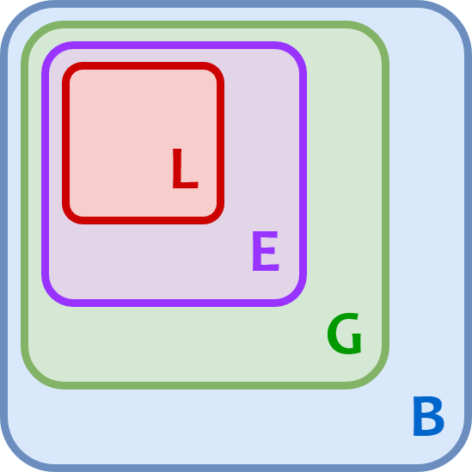

If the interpreter doesn’t find the name in any of these locations, then Python raises a NameError exception.

